**Project 01 - Create your own Learning Management System**

## Initialize the Application

The version of Node in the local machine is

*v16.13.0*

The version of npm (node package manager) in the local machine is

*8.3.0*

Initialize the application by typing the following command in the terminal

*npm init --yes*

install the required packages (latest) by typing the following commands in the terminal

*npm install mongodb*

*npm i express*

*npm i mocha*

*npm i nodemon*

nodemon automatically incorporate changes to js files without the need to stop and restart the server each time a change is made to the files

add *"start": "nodemon app.js"* to *“scripts”* section of package.json

|  |
| --- |
| package.json |
| {  "name": "lms",  "version": "1.0.0",  "description": "",  "main": "index.js",  "scripts": {  "test": "echo \"Error: no test specified\" && exit 1",  "start": "nodemon app.js"  },  "keywords": [],  "author": "",  "license": "ISC",  "dependencies": {  "express": "4.17.2",  "mocha": "9.2.0",  "mongodb": "4.3.1",  "nodemon": "2.0.15"  }  } |

Kindly note the carat ‘^’ sign is removed before the version numbers so that the version is locked to avoid version mismatch errors in case project is shared between teams.

Start Express on localhost:3000

|  |
| --- |
| app.js |
| const express = require('express');  const app = express();  app.use('/',(req,res)=>{  res.sendFile(__dirname+"/views/"+"home.html");  })  app.listen(3000, ()=>{  console.log("Server is listening on port 3000");  }); |
| home.html |
| <!DOCTYPE html>  <html lang="en">  <head>  <meta charset="UTF-8">  <meta http-equiv="X-UA-Compatible" content="IE=edge">  <meta name="viewport" content="width=device-width, initial-scale=1.0">  <title>Home</title>  </head>  <body>  <h1>This is the homepage</h1>  </body>  </html> |

Start express by typing the following command in the terminal

*npm start*

the homepage will be displayed in the browser at http://localhost:3000

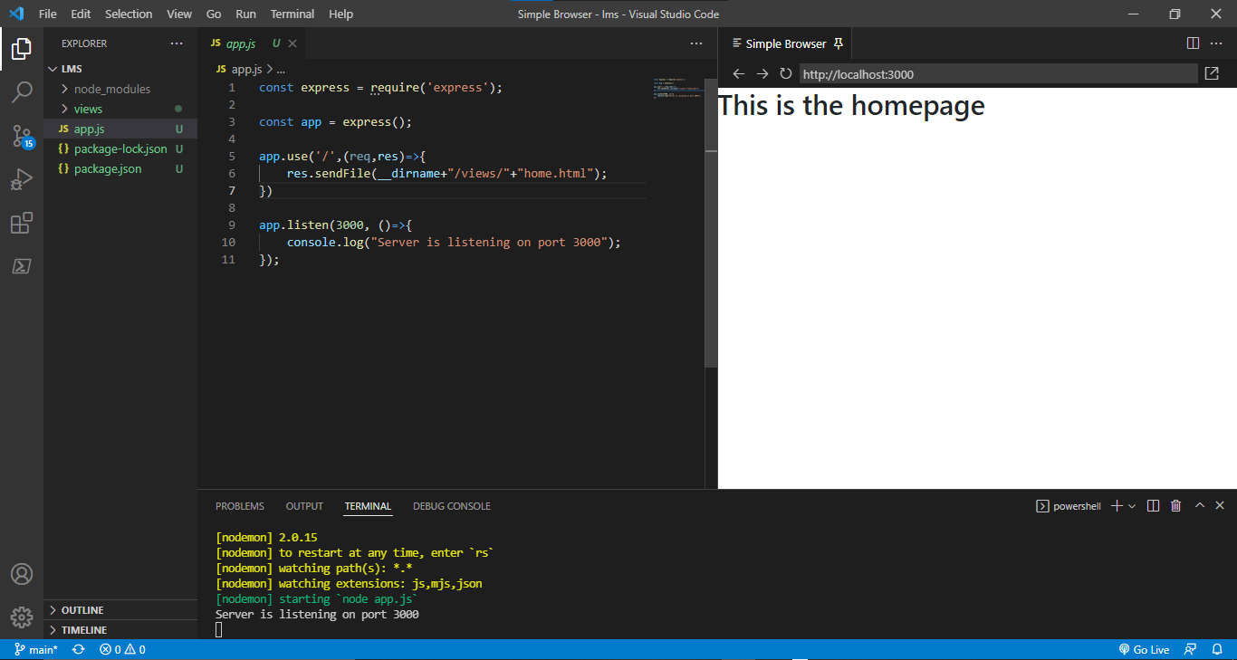

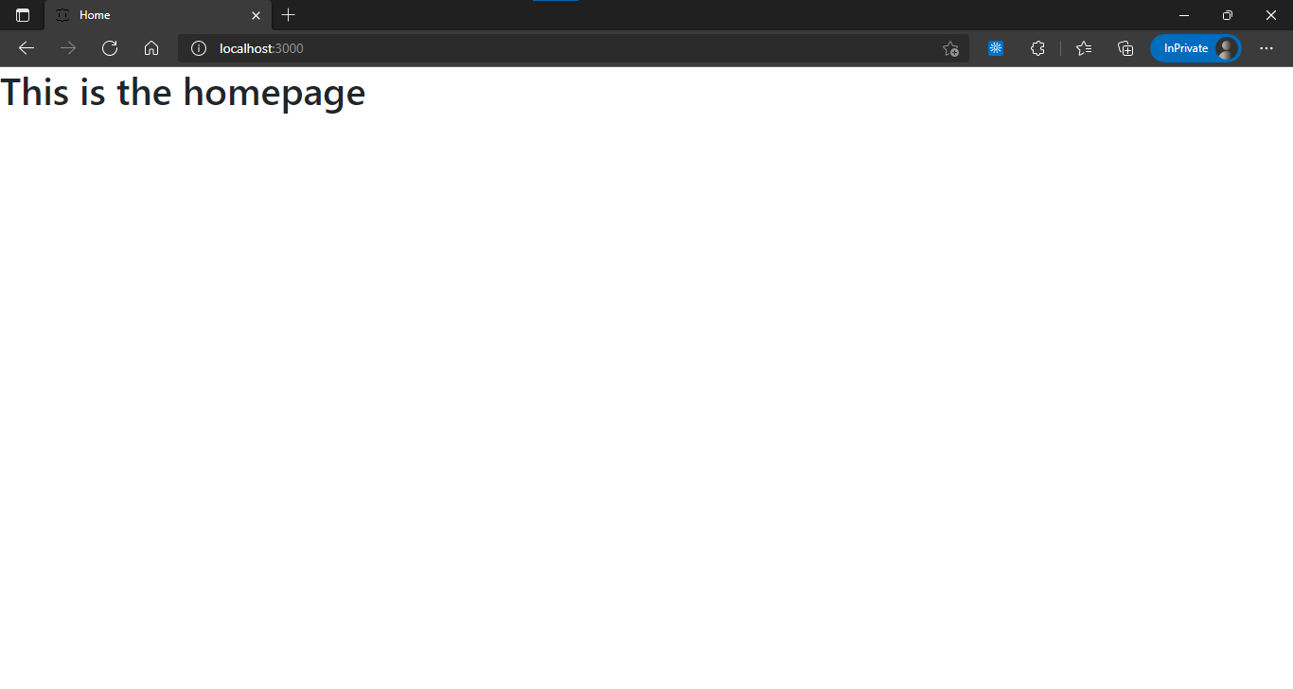

## Setup the routes

Setup routing for user and course. The user route will contain all the routes for views like registration, login, edit user and navbar and the course route will contain all the routes for views like course update, course delete and dashboard. The routing will be added to app.js as middleware.

|  |
| --- |
| user_routes.js |
| const express = require('express');  const path = require('path');  const router = express.Router();  router.get('/home', (req,res)=>{  res.sendFile(path.join(__dirname,'../','views','home.html'));  });  router.get('/navbar', (req,res)=>{  res.sendFile(path.join(__dirname,'../','views','navbar.html'));  });  router.get('/edit', (req,res)=>{  res.sendFile(path.join(__dirname,'../','views','user_edit.html'));  });  module.exports = router; |
| course_routes.js |
| const express = require('express');  const path = require('path');  const router = express.Router();  router.get('/', (req,res)=>{  res.sendFile(path.join(__dirname,'../','views','course_new.html'));  });  module.exports = router; |
| app.js |
| const express = require('express');  const userRoutes = require('./routes/user_routes');  const courseRoutes = require('./routes/course_routes');  const app = express();  app.use('/user',userRoutes);  app.use('/course',courseRoutes);  app.listen(3000, ()=>{  console.log("Server is listening on port 3000");  }); |

## Create the Views

Install bootstrap using the following CDN link provided by www.bootstrapcdn.com

https://cdn.jsdelivr.net/npm/bootstrap@5.1.3/dist/css/bootstrap.min.css

add the below tag to the head tag in the html file

<link rel="stylesheet" href="https://cdn.jsdelivr.net/npm/bootstrap@5.1.3/dist/css/bootstrap.min.css">

Type the following command in terminal to install bootstrap

*npm i bootstrap*

Type the code to display the required forms in homepage

|  |
| --- |
| home.html |
| <!DOCTYPE html>  <html lang="en">  <head>  <meta charset="UTF-8">  <meta http-equiv="X-UA-Compatible" content="IE=edge">  <meta name="viewport" content="width=device-width, initial-scale=1.0">  <title>Home</title>  <link rel="stylesheet" href="https://cdn.jsdelivr.net/npm/bootstrap@5.1.3/dist/css/bootstrap.min.css" crossorigin="anonymous">  </head>  <body>  <div class="container">  <form action="">  <div class="card style="margin-top: 10%; padding-top: 5%; padding-bottom: 5%;">  <div class="row justify-content-center">  <div class="col-6 align-self-center">  <h2>New to EGyan? Sign up for free!</h2>  <div class="mb-3">  <div class="row g-2">  <div class="col-8">  Full name<input class="form-control" name="regName" type="text" />  </div>  <div class="col">  Type<input class="form-control" name="regType" type="text" />  </div>  </div>  </div>  <div class="mb-3">  Email ID<input class="form-control" name="regEmail" type="email" placeholder="you@example.com"/>  </div>  <div class="mb-3">  <div class="row g-2">  <div class="col">  Password<input class="form-control" name="regPassword" type="password" />  </div>  <div class="col">  Confirm Password<input class="form-control" name="regConfPassword" type="password" />  </div>  </div>  </div>  <div class="mb-3 d-grid gap-2">  <button class="btn btn-primary" type="submit" name="register">Register Now!</button>  </div>  </div>  <div class="col-5">  <h2>Have an account? Log in now!</h2>  <div class="mb-3">  Email ID<input class="form-control" name="LogEmail" type="email" />  </div>  <div class="mb-3">  Password<input class="form-control" name="LogPassword" type="password" />  </div>  <div class="mb-3 d-grid gap-2">  <button class="btn btn-primary" type="submit" name="login">Login</button>  </div>  </div>  </div>  </div>  </form>  </div>  </body>  </html> |

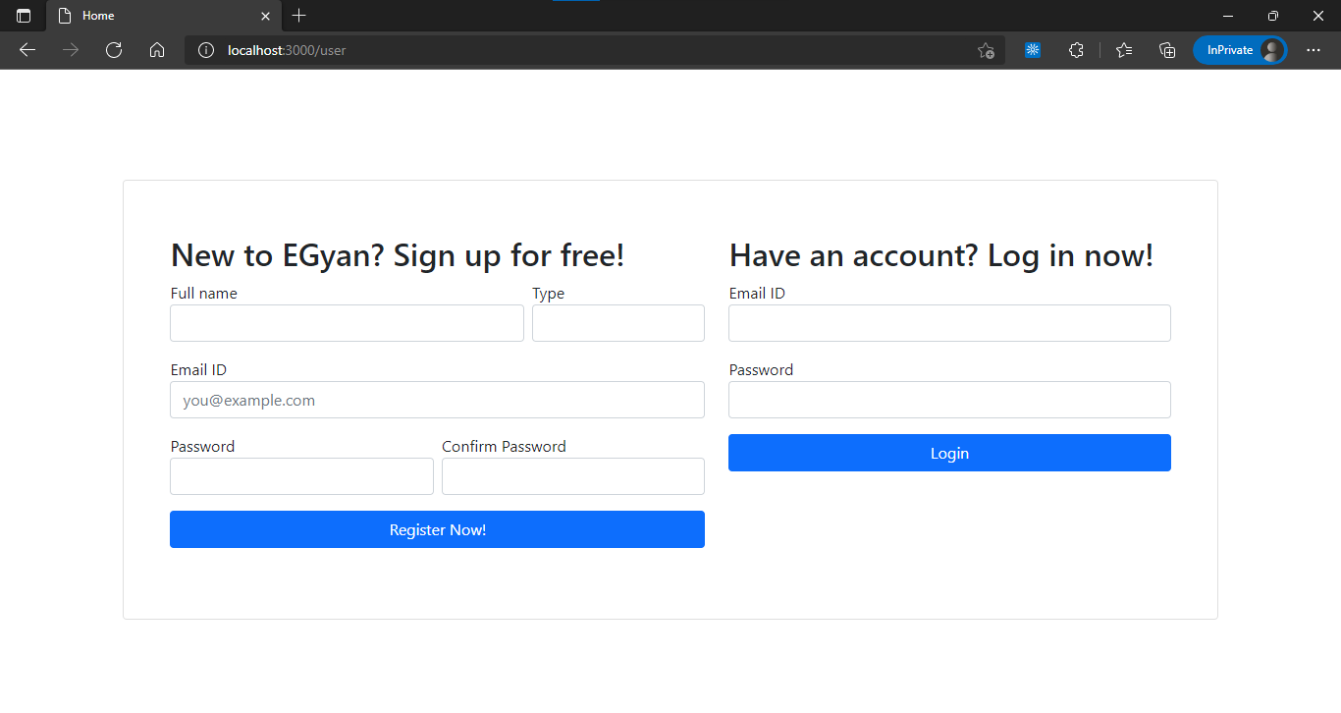

|  |
| --- |
| navbar.html |
| <!DOCTYPE html>  <html lang="en">  <head>  <meta charset="UTF-8">  <meta http-equiv="X-UA-Compatible" content="IE=edge">  <meta name="viewport" content="width=device-width, initial-scale=1.0">  <title>Navbar</title>  <link rel="stylesheet" href="https://cdn.jsdelivr.net/npm/bootstrap@5.1.3/dist/css/bootstrap.min.css" crossorigin="anonymous">  <link href="https://fonts.googleapis.com/icon?family=Material+Icons" rel="stylesheet">  </head>  <body>  <nav class="navbar navbar-dark bg-dark text-white" style="position: fixed; padding: 1%; height: 100%;">  <ul class="nav flex-column">  <div class="navbar-brand" style="position: fixed; top: 5%;">  <h2>Welcome,</h2>  <h2>AAAAA</h2>  </div>  <li class="nav-item">  <a class="nav-link text-white" href="#">  <span class="material-icons">home</span>  Dashboard  </a>  </li>  <li class="nav-item">  <a class="nav-link text-white" href="#">  <span class="material-icons">library_books</span>  Manage Courses</a>  </li>  <li class="nav-item">  <a class="nav-link text-white" href="#">  <span class="material-icons">description</span>  Manage Lessons  </a>  </li>  <li class="nav-item">  <a class="nav-link text-white" href="#">  <span class="material-icons">download</span>  Manage Course Material  </a>  </li>  <li class="nav-item">  <a class="nav-link text-white" href="#">  <span class="material-icons">person</span>  Edit Profile  </a>  </li>  <button class="btn btn-primary" type="button" style="position: fixed; bottom: 10%; width: 10%;">Logout</button>  </ul>  </nav>  </body>  </html> |

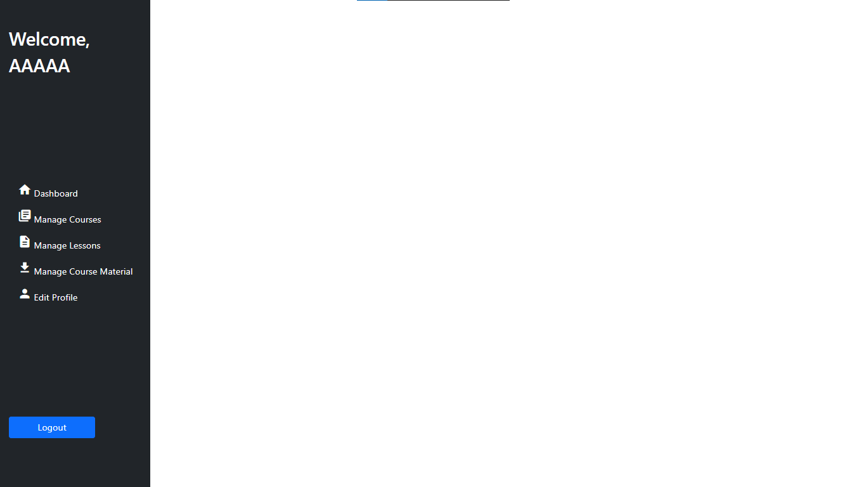

|  |
| --- |
| user_edit.html |
| <!DOCTYPE html>  <html lang="en">  <head>  <meta charset="UTF-8">  <meta http-equiv="X-UA-Compatible" content="IE=edge">  <meta name="viewport" content="width=device-width, initial-scale=1.0">  <title>User</title>  <link rel="stylesheet" href="https://cdn.jsdelivr.net/npm/bootstrap@5.1.3/dist/css/bootstrap.min.css" crossorigin="anonymous">  </head>  <body>  <div class="container">  <form action="">  <div class="row justify-content-around" style="margin-top: 10%; padding-top: 5%; padding-bottom: 5%;">  <div class="card col-4">  <h2>Change Profile</h2>  <div class="mb-3">  Full name<input class="form-control" name="regName" type="text" placeholder="aa" />  </div>  <div class="mb-3">  Email ID<input class="form-control" name="regPassword" type="password" placeholder="aa@gmail.com" />  </div>  <div class="mb-3 d-grid gap-2">  <button class="btn btn-primary" type="submit" name="changeProfile">Change Profile</button>  </div>  </div>  <div class="card col-4">  <h2>Change Password</h2>  <div class="mb-3">  New Password<input class="form-control" name="regPassword" type="password" />  </div>  <div class="mb-3">  Confirm New Password<input class="form-control" name="regConfPassword" type="password" />  </div>  <div class="mb-3 d-grid gap-2">  <button class="btn btn-primary" type="submit" name="changePassword">Change Password</button>  </div>  </div>  </div>  </form>  </div>  </body>  </html> |

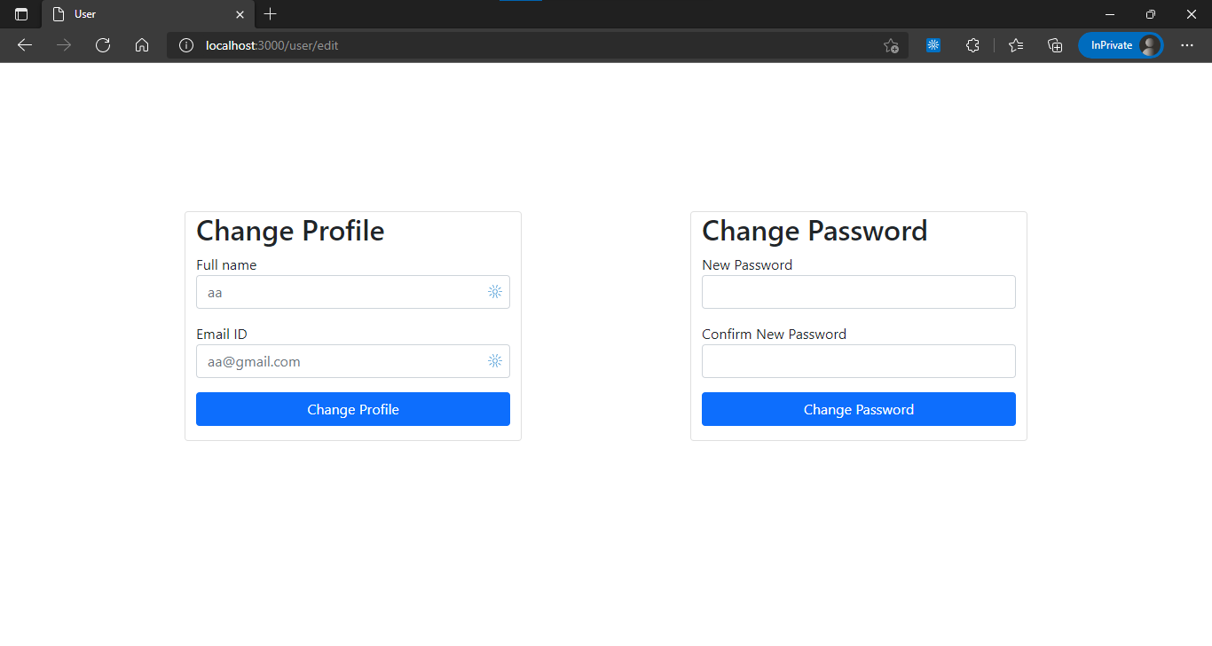

|  |
| --- |
| course_new.html |
| <!DOCTYPE html>  <html lang="en">  <head>  <meta charset="UTF-8">  <meta http-equiv="X-UA-Compatible" content="IE=edge">  <meta name="viewport" content="width=device-width, initial-scale=1.0">  <title>New Course</title>  <link rel="stylesheet" href="https://cdn.jsdelivr.net/npm/bootstrap@5.1.3/dist/css/bootstrap.min.css" crossorigin="anonymous">  <script src="//cdn.ckeditor.com/4.17.2/standard/ckeditor.js"></script>  </head>  <body>  <div class="container">  <form action="">  <div class="card" style="margin: 5%; padding-top: 2%; padding-bottom: 2%;">  <div class="row justify-content-center">  <div class="col-11">  <h2>Create New Course</h2>  <div class="mb-3">  <div class="row g-2">  <div class="col-8">  Course Name<input class="form-control" name="courseName" type="text" />  </div>  <div class="col">  Category  <select class="form-control" name="courseCategory" >  <option value="1">Web Development</option>  <option value="2">Data Science</option>  </select>  </div>  </div>  </div>  <div class="mb-3">  One Liner<input class="form-control" name="courseOneLiner" type="text" />  </div>  <div class="mb-3">  <div class="row g-3">  <div class="col">  Duration in Hours<input class="form-control" name="courseDuration" type="text" />  </div>  <div class="col">  Language<input class="form-control" name="courseLanguage" type="text" />  </div>  <div class="col">  Upload Cover Photo<input class="form-control" name="courseCoverPhoto" type="file" />  </div>  </div>  </div>  <div class="mb-3">  Description  <textarea class="form-control" name="courseDescription"></textarea>  <script type="text/javascript">  CKEDITOR.replace( 'courseDescription' );  </script>  </div>  <button class="btn btn-primary" type="submit" style="float: right;">Create New Course</button>  </div>  </div>  </div>  </form>  </div>  </body>  </html> |

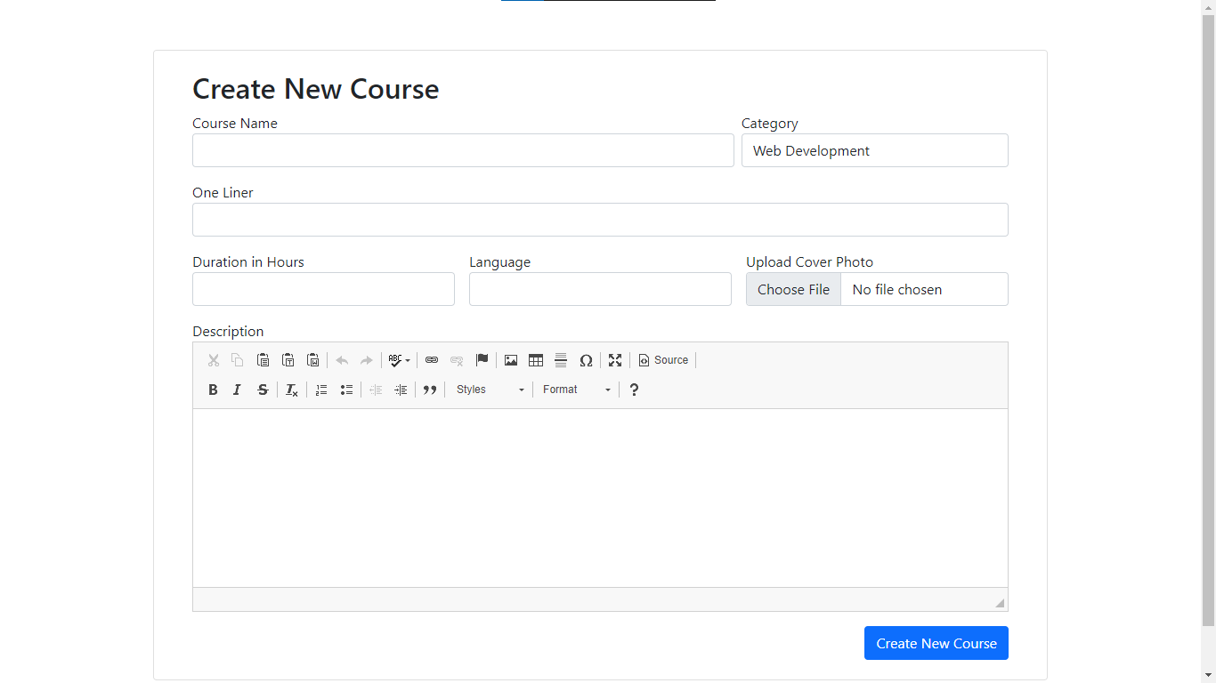

|  |
| --- |
| dashboard.html |
| <!DOCTYPE html>  <html lang="en">  <head>  <meta charset="UTF-8">  <meta http-equiv="X-UA-Compatible" content="IE=edge">  <meta name="viewport" content="width=device-width, initial-scale=1.0">  <title>Dashboard</title>  <link rel="stylesheet" href="https://cdn.jsdelivr.net/npm/bootstrap@5.1.3/dist/css/bootstrap.min.css" crossorigin="anonymous">  </head>  <body>  <div class="container">  <div class="card" style="margin: 20%; padding-top: 5%; padding-bottom: 5%;">  <div class="row justify-content-center">  <div class="col-11">  <h2>My Courses</h2>  <table class="table table-bordered">  <thead class="table-dark">  <tr>  <th scope="col">#</th>  <th scope="col">Photo</th>  <th scope="col">Course Name</th>  <th scope="col">Category</th>  <th scope="col">Duration</th>  <th scope="col"></th>  </tr>  </thead>  <tbody>  <tr>  <th scope="row">1</th>  <td>  <img src="https://seeklogo.com/images/N/nodejs-logo-065257DE24-seeklogo.com.png" style="height: 75px; width: 150px;">  </td>  <td>Node.js</td>  <td>Web Development</td>  <td>1 Hours</td>  <td>  <button class="btn btn-primary" type="button">View</button>  </td>  </tr>  </tbody>  </table>  </div>  </div>  </div>  </div>  </body>  </html> |

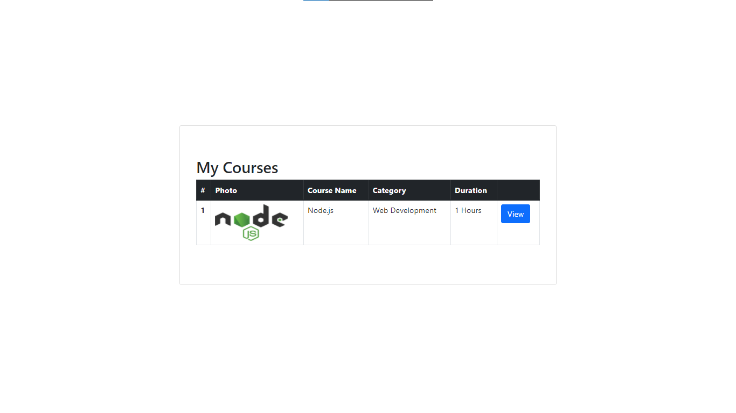

|  |
| --- |
| course_update.html |
| <!DOCTYPE html>  <html lang="en">  <head>  <meta charset="UTF-8">  <meta http-equiv="X-UA-Compatible" content="IE=edge">  <meta name="viewport" content="width=device-width, initial-scale=1.0">  <title>Update Course</title>  <link rel="stylesheet" href="https://cdn.jsdelivr.net/npm/bootstrap@5.1.3/dist/css/bootstrap.min.css" crossorigin="anonymous">  <script src="//cdn.ckeditor.com/4.17.2/standard/ckeditor.js"></script>  </head>  <body>  <div class="container">  <form action="">  <div class="card" style="margin: 5%; padding-top: 2%; padding-bottom: 2%;">  <div class="row justify-content-center">  <div class="col-11">  <h2>Update Course</h2>  <div class="mb-3">  Select Course  <select class="form-control" name="courseName">  <option value="1">Node.js</option>  <option value="2">Angular.js</option>  </select>  </div>  <div class="mb-3">  <div class="row g-2">  <div class="col-8">  Course Name<input class="form-control" name="courseName" type="text" />  </div>  <div class="col">  Category  <select class="form-control" name="courseCategory">  <option value="1">Web Development</option>  <option value="2">Data Science</option>  </select>  </div>  </div>  </div>  <div class="mb-3">  One Liner<input class="form-control" name="courseOneLiner" type="text" />  </div>  <div class="mb-3">  <div class="row g-3">  <div class="col">  Duration in Hours<input class="form-control" name="courseDuration" type="text" />  </div>  <div class="col">  Language<input class="form-control" name="courseLanguage" type="text" />  </div>  <div class="col">  Upload Cover Photo<input class="form-control" name="courseCoverPhoto" type="file" />  </div>  </div>  </div>  <div class="mb-3">  Description  <textarea class="form-control" name="courseDescription"></textarea>  <script type="text/javascript">  CKEDITOR.replace( 'courseDescription' );  </script>  </div>  <button class="btn btn-primary" type="submit" style="float: right;">Update Course</button>  </div>  </div>  </div>  </form>  </div>  </body>  </html> |

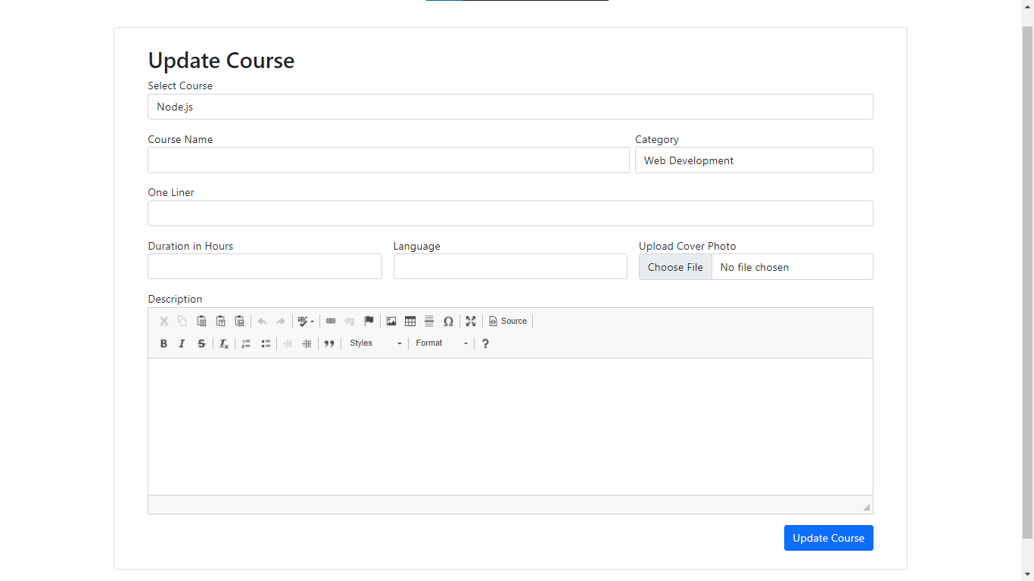

|  |
| --- |
| course_delete.html |
| <!DOCTYPE html>  <html lang="en">  <head>  <meta charset="UTF-8">  <meta http-equiv="X-UA-Compatible" content="IE=edge">  <meta name="viewport" content="width=device-width, initial-scale=1.0">  <title>Delete Course</title>  <link rel="stylesheet" href="https://cdn.jsdelivr.net/npm/bootstrap@5.1.3/dist/css/bootstrap.min.css" crossorigin="anonymous">  </head>  <body>  <div class="container">  <div class="card" style="margin: 20%; padding-top: 5%; padding-bottom: 5%;">  <div class="row justify-content-center">  <div class="col-11">  <h2>Delete Course</h2>  <table class="table table-bordered">  <thead class="table-dark">  <tr>  <th scope="col">#</th>  <th scope="col">Photo</th>  <th scope="col">Course Name</th>  <th scope="col">Category</th>  <th scope="col">Duration</th>  <th scope="col"></th>  </tr>  </thead>  <tbody>  <tr>  <th scope="row">1</th>  <td>  <img src="https://seeklogo.com/images/N/nodejs-logo-065257DE24-seeklogo.com.png" style="height: 75px; width: 150px;">  </td>  <td>Node.js</td>  <td>Web Development</td>  <td>1 Hours</td>  <td>  <button class="btn btn-danger" type="button">Delete</button>  </td>  </tr>  </tbody>  </table>  </div>  </div>  </div>  </div>  </body>  </html> |

